**Networking**

Class --

**Lecture --**

**Routing**

**.**



**Lab Objectives:**

* Introduction.
* To route, a router needs to know.
* Router types.
* Static routes.
* Static routing configuration.
* Verifying the static routing configuration.
* Types or classes of routing protocols.

**Introduction**

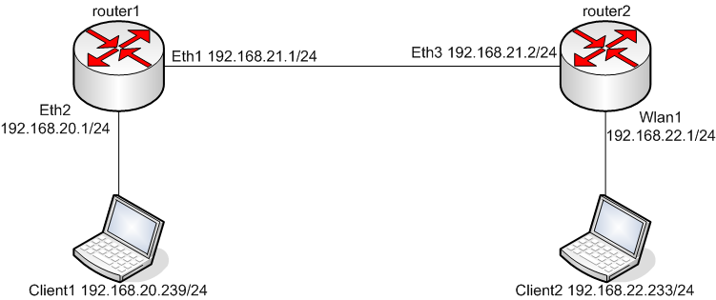

**Routing *is a key feature of the Internet because it enables messages to pass from one computer to another and eventually reach the target machine. Each intermediary computer performs* routing *by passing along the message to the next computer.***

**Routing *refers to establishing the routes that data packets take on their way to a particular destination. Which is performed by layer 3 (or network layer) devices in order to deliver the packet by choosing an optimal path from one network to another.***

***Example 1:***

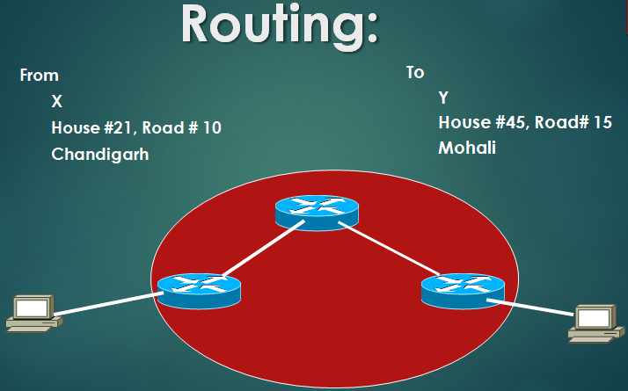

***Example 2:***

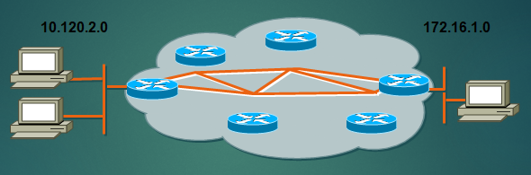

**To route, a router needs to know**

* ***Destination addresses***
* ***Sources it can learn from***
* ***Possible routes***
* ***Best route***

**Router Types**

* ***Static routing - network administrator configures information about remote networks manually. They are used to reduce overhead and for security.***
* ***Dynamic routing - information is learned from other routers, and routing protocols adjust routes automatically.***
* ***Because of the extra administrative requirements, static routing does not have the scalability of dynamic routing.***

**Static Routes**

* ***Benefits***
  + ***No overhead on the router CPU***
  + ***No bandwidth usage between routers***
  + ***Adds security***
* ***Disadvantage***
  + ***Administrator must really understand the inter-network***
  + ***If a network is added to the inter-network, the administrator has to add a route to it on all routers***
  + ***Not feasible in large networks***

**Static routing examples**

**Routing Implementation:**

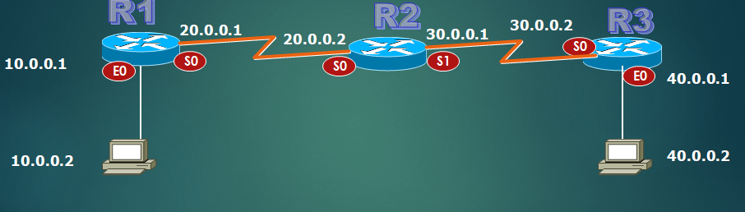

**Static routing configuration**

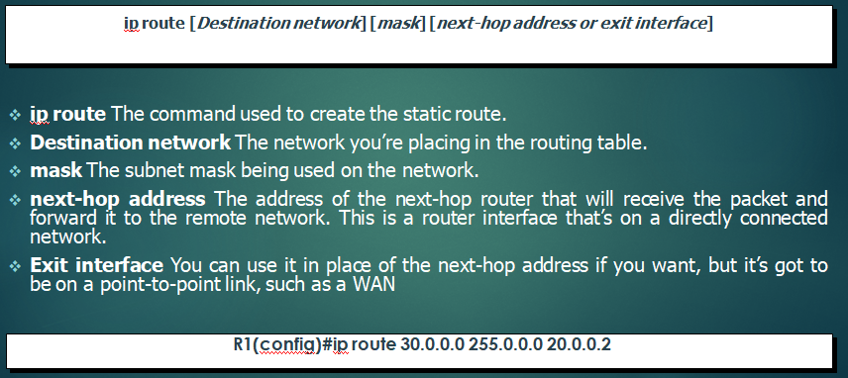

**Verifying Static Route Configuration**

* ***After static routes are configured it is important to verify that they are present in the routing table and that routing is working as expected.***
* ***The command show running-config is used to view the active configuration in RAM to verify that the static route was entered correctly.***
* ***The show ip route command is used to make sure that the static route is present in the routing table.***

**Types or Classes of Routing Protocols**

* ***Distance Vector***
  + ***RIP V1***
  + ***IGRP***
  + ***RIP V2***
* ***Link state***
  + ***OSPF***
* ***Hybrid***
  + ***EIGRP***



***End Of this slide***